Artificial Neural Network

Observation Report

Master of Technology

in

Computer Science and Engineering

Submitted by

Mihir Chouhan

25CSE2014

Submitted to
Dr. Pravati Swain

Department of Computer Science and Engineering
NIT Goa



Implementation of LeNet-5 CNN on MNIST with Real-World Input Testing

1. Objective:
Implementation and Performance Analysis of LeNet-5 on MNIST Dataset with Real-World Handwritten Digit Recognition

2. Abstract:
This project implements the LeNet-5 Convolutional Neural Network (CNN) for handwritten digit classification using the MNIST dataset. In addition to standard training and evaluation, the model is tested on real-world handwritten digits provided by the user. The study highlights the impact of preprocessing techniques on model accuracy when dealing with non-MNIST inputs. The model achieves ~98–99% accuracy on MNIST and demonstrates reasonable performance on real-world inputs after preprocessing.

3. Introduction:
Deep learning, particularly Convolutional Neural Networks (CNNs), has revolutionized image recognition tasks. LeNet-5, developed by Yann LeCun, is one of the earliest CNN architectures designed for digit recognition.
This project not only implements LeNet-5 but also evaluates its performance on:
- Standard dataset (MNIST)
- User-provided handwritten digits

4. Dataset Description:

- Dataset: MNIST
- Training Samples: 60,000
- Testing Samples: 10,000
- Image Size: 28 × 28
- Colour: Grayscale

5. Layer Details
Layer | Type | Output Shape | Activation
Input | Image | 28×28×1 | —
C1 | Conv2D (6 filters, 5×5) | 24×24×6 | tanh
S2 | Avg Pool (2×2) | 12×12×6 | —
C3 | Conv2D (16 filters, 5×5) | 8×8×16 | tanh
S4 | Avg Pool (2×2) | 4×4×16 | —
Flatten | — | 256 | —
FC1 | Dense (120) | 120 | tanh
FC2 | Dense (84) | 84 | tanh
Output | Dense (10) | 10 | softmax

6. Parameter Calculation
- C1: 156
- C3: 2,416
- FC1: 30,840
- FC2: 10,164
- Output: 850
Total Parameters: 44,426

7. Activation Functions
- Hidden Layers: tanh
- Output Layer: softmax

8. Training Configuration
- Optimizer: Adam
- Loss Function: Categorical Cross-Entropy
- Epochs: 10
- Batch Size: 128

9. Results on MNIST Dataset
Accuracy
- Training Accuracy: ~99%
- Testing Accuracy: ~98%
Accuracy Graph
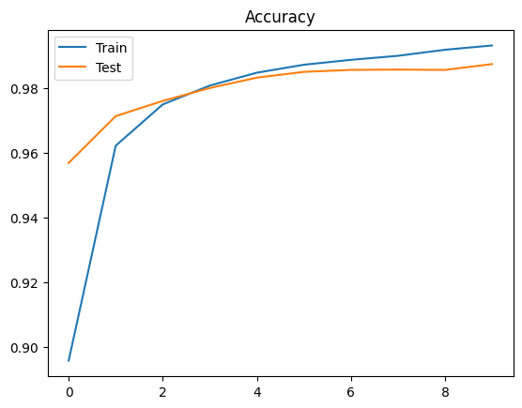
Fig1. Testing Accuracy vs Validation Accuracy
Loss Graph
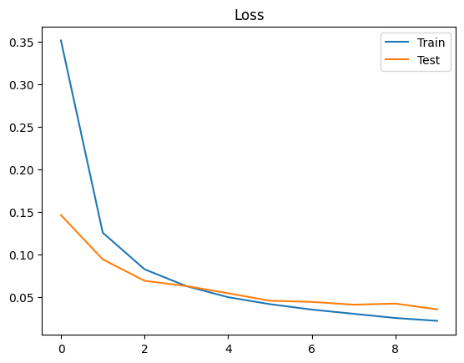
Fig2. Testing Loss vs Validation Loss

10. Real-World Input Testing

Fig3. Custom Input Image

Problem Statement
The model trained on MNIST was tested on user-provided handwritten digits (e.g., images drawn on paper or a notebook). These images differ significantly from MNIST data.

Observed Challenges
- Background mismatch (white vs black)
- Presence of noise (ruled lines, shadows)
- Digit misalignment
- Thickness variation in strokes

Preprocessing Applied
To overcome these issues, the following preprocessing steps were implemented:
- Grayscale conversion
- Resizing to 28×28
- Gaussian blur (noise reduction)
- Thresholding (background removal)
- Colour inversion
- Normalization

Results After Preprocessing
- Accuracy improved significantly compared to raw input
- Model correctly predicts most digits when preprocessing is applied
- Confidence score improves with cleaner input

11. Observations
- The model performs exceptionally well on MNIST due to clean and standardized data
- Performance drops when tested on real-world images due to domain mismatch
- Proper preprocessing significantly improves prediction accuracy
- Background noise (especially ruled lines) negatively impacts convolution layers
- Centered and bold digits produce the best results
- Thresholding and inversion are critical steps for matching MNIST format

12. Advantages
- High accuracy on the standard dataset
- Simple and efficient architecture
- Easy to implement and train

13. Limitations
- Sensitive to noisy inputs
- Poor generalization without preprocessing
- Not suitable for complex real-world images without enhancement

14. Conclusion
The LeNet-5 model successfully achieves high accuracy on the MNIST dataset. However, real-world handwritten inputs introduce challenges due to differences in data distribution. By applying appropriate preprocessing techniques, the model can effectively generalize to user-provided inputs. This demonstrates the importance of data consistency and preprocessing in deep learning applications.

15. Future Scope
- Train model on augmented real-world data
- Use advanced CNNs (ResNet, VGG)
- Implement real-time digit recognition
- Improve preprocessing pipeline with edge detection

16. References
- Yann LeCun et al., “Gradient-Based Learning Applied to Document Recognition”
- MNIST Dataset
- TensorFlow Documentation

